Giving Tuesday Email Campaign

Before you begin, please take a few minutes to determine…
- What is the next milestone in your child’s fundraising campaign?
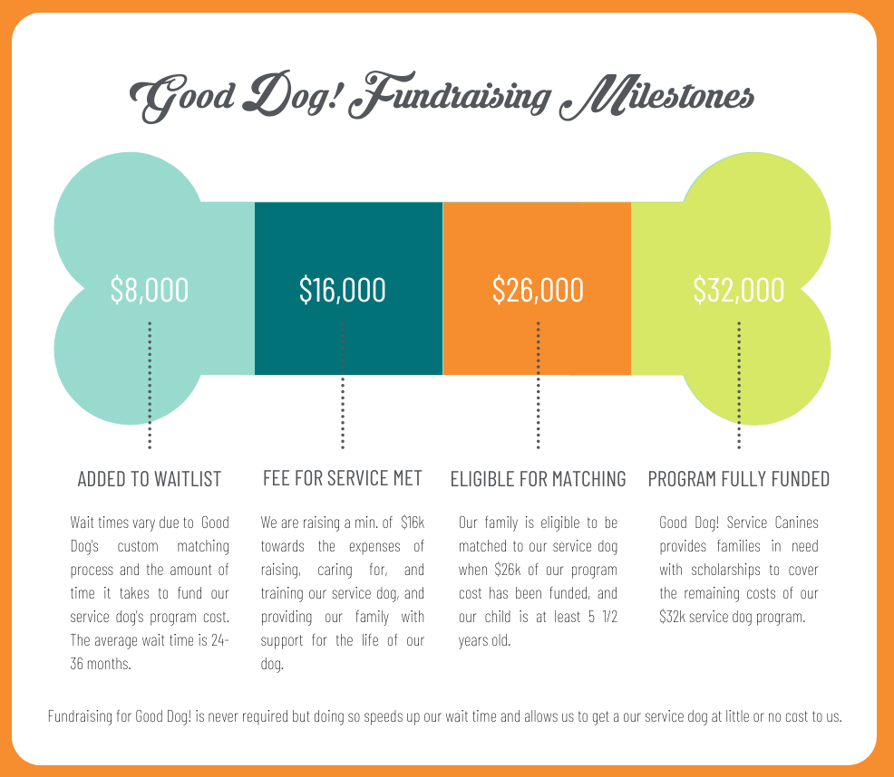
Here are some suggested ideas for determining your campaign goals…
- Newly accepted to the program? Your campaign goal is to kick off the first $2k of your fundraising efforts.
- Recently started fundraising? Your campaign goal is to get to $4k, the halfway mark of getting on the official Good Dog! waiting list.
- Already raised $4k? Your campaign goal is to get to $8k to get on the official Good Dog! waiting list!
- Already on the waitlist? Your campaign goal is to get to $16k to fulfill your family’s fee for service requirement.
- Already fulfilled your family’s fundraising requirement? Your campaign goal is to become eligible for matching by reaching the $26k milestone.
- Already matched? Your campaign goal is to help raise the remaining amount of your family’s $32k service dog program cost.
My Giving Tuesday campaign goal is to: ___________________________________________________________________

- How much do you need to raise to get to the next milestone?
To determine, subtract the current amount you’ve raised from the amount of the campaign goal amount listed above. For instance, if you’ve currently raised $3,125 and your campaign goal is to get your child on the official Good Dog! waiting list, you would subtract the amount your raised from the milestone amount. $8,000 - $3,125 = $4,875.
Of course, this is just a suggestion based on accomplishing milestones. Your campaign goal amount may be any amount you wish.
My Giving Tuesday campaign goal amount is: $____________________________

- Do you have a matching donor? If so, how much will be matched?
Please note, there are certain limitations in recognizing corporate sponsors. Contact me at kimberly@gooddogautism.org if you have a matching donor so we can discuss in full detail. Thanks!
My matching donor is: _______________________________________________
The matching donation amount is $_____________________________________
Don’t have a matching donor? No worries, just take out the sections in the email templates below that mention them. In its place, expand on how a service dog will help your child.

- How will your child benefit from their service dog?
Think about how your child’s diagnosis impacts their daily life and how a service dog may help them. For example:
- Sensory Seeking Behavior – during a visit to a family friends house, my child was running and crashing into their couch because he was having a sensory meltdown.
- A service dog may serve as an appropriate way to get sensory input. His service dog could provide deep pressure to help alleviate the need to crash. We could refocus their attention away from the couch and on to his service dog.
Some ways my child would benefit from their service dog are:
____________________________________________________________________________________________________________________________________________________________________________________________________________________________________________________________________________
Need help coming up with benefits? Reach out to me at kimberly@gooddogautism.org!
Now that you’ve completed the above answers, you’re ready to customize the following email templates! As always, if you have any questions, would like further help customizing your emails, or simply want feedback, contact me at kimberly@gooddogautism.org.

10 DAYS PRIOR
- When: November 19
- Who: All Supporters
- What: Announce your Giving Tuesday Fundraiser. Explain the purpose of the giving day, your fundraising goals, and the impact you plan to make. Ask recipients to spread the word, and provide them with an option to give now.
- CTA: Donate Now
- Subject: Will You Celebrate Giving Tuesday with Us?

Dear [NAME],
The holiday season is just around the corner, and we invite you to kick it off with us on Giving Tuesday!
Giving Tuesday is a global day of giving back. On the Tuesday following Thanksgiving, you’ll have the chance to join people around the world and support a cause close to your heart.
This Giving Tuesday, help us make it pawsible in getting [CHILD NAME] [HIS/HER] service dog. By joining the movement, you’re helping [CAMPAIGN GOAL].
Mark your calendars for November 29th, spread the world, and stay tuned for more details!
[DONATE NOW – embed link to fundraising website]
Wags + Gratitude,
[YOUR NAME]

7 DAYS PRIOR
- When: November 22
- Who: All Supporters
- What: Remind supporters that Giving Tuesday is approaching. Mention any matching challenges*, and ask supporters to spread the word and follow you on social media for regular updates.
- CTA: Donate Now
- Subject: Let’s Kick Off the Giving Season Together

AFTER BLACK FRIDAY AND CYBER MONDAY, JOIN US IN KICKING OF THE HOLIDAY SEASON ON GIVING TUESDAY!
Dear NAME,
On this global day of giving, we’re raising [$GOAL AMOUNT] to get [CHILD NAME] the life-changing gift of a service dog. We’re also excited to announce that [MATCHING DONOR NAME] has stepped up to match the first [$MATCHING AMOUNT] raised with a donation to Good Dog! Service Canines. Now is your chance to make [TWICE THE/AN] impact!
Ways to gear up for Giving Tuesday:
- Donate [imbed link to website] to lock in your gift
- Follow us on [FACEBOOK/INSTAGRAM/TWITER – imbed link to social media account] for exciting updates
- Share this message with friends and family – and encourage them to join the movement!
We’ve got just one week left until Giving Tuesday. Let’s do this!
[DONATE NOW – embed link to website]
Wags + Gratitude,
[YOUR NAME]

*If you don’t have a matching donor, no worries – just leave out those parts in the emails. In its place, expand on your message of why a service dog will benefit your child.

1 DAY PRIOR
- When: November 28
- Who: All Supporters
- What: Send an email that reminds supporters to give the next day and share the campaign with friends and family. Be sure to remind them of any matching challenges you have going on.
- CTA: Donate Now
- Subject: Are you ready for Giving Tuesday?

BUY A GIFT FOR YOURSELF ON CYBER MONDAY… BUT DON’T FORGET TO SHARE THE LOVE WITH OTHERS TOMORROW, ON GIVING TUESDAY!
Dear NAME,
Your gift to [CHILD’S NAME] fundraising campaign has the chance to be DOUBLED thanks to a generous donor who has committed to match the first [$MATCHING AMOUNT] and donate it to Good Dog! Service Canines.
What’s all this again?
Tomorrow, as people around the world support important causes, donate to help give [CHILD’S NAME] the service dog [HE/SHE] needs to [BENEFIT]. Spread the word to friends and family who also want to make an impact.
We’ll be in touch soon to ring in Giving Tuesday.
[DONATE NOW – embed link to campaign]
Wags + Gratitude,
[YOUR NAME]

DAY OF GIVING TUESDAY
EMAIL #1
- When: November 29 – early morning
- Who: All Supporters
- What: Announce that Giving Tuesday is here and rally supporters to donate.
- CTA: Give Now
- Subject: Today’s the Day to #MakeItPawsible in [CHILD’S NAME] World
IT’S A GOOD DAY TO GIVE TOWARDS [CHILD’S NAME] GOOD DOG!
Dear NAME,
During the next 24 hours, people around the world will come together to celebrate generosity and make an impact. Our goal is to raise [$GOAL AMOUNT] for [CHILD’S NAME] Good Dog! Service Canines fundraiser so [CAMPAIGN GOAL]. With your help, we can make it pawsible!
Your gift can also make TWICE the impact, thanks to [MATCHING DONOR NAME], who will match the first [$MATCHING AMOUNT], dollar-for-dollar, and donate it to Good Dog! Service Canines.
Will you help us get [CHILD’S NAME] [HIS/HER] service dog?
[GIVE NOW – imbed link to website]
Wags + Gratitude,
[YOUR NAME]

DAY OF GIVING TUESDAY
EMAIL #2
- When: November 29 - noon
- Who: Contacts who haven’t donated yet
- What: Update your community with the amount raised so far. Include a picture of your child holding their Dog Bone Giving Meter with the progress amount colored in. If your match challenge is still going, mention it here as well. It’s also a good idea to encourage those who’ve already donated to share the message.
- CTA: Give Now
- Subject: We’ve got something pawsome to celebrate!
THANKS TO OVER [#] PAWSOME DONORS, WE’RE JUST OVER HALFWAY TO OUR GOAL!
Dear [NAME],
If you haven’t given yet, you can make a quick donation that will help us get [CHILD’S NAME] their service dog.
Let’s keep this rolling. Giving Tuesday comes but once a year, so celebrate today and help us cross the finish line strong!
[GIVE NOW – imbed link to website]
Wags + Gratitude,
[YOUR NAME]

DAY OF GIVING TUESDAY
EMAIL #3
- When: November 29 - Evening
- Who: Supporters who have NOT donated
- What: With just a few hours left, ramp up the urgency for your supporters to help you reach your fundraising goal. Include a picture of your child holding an updated Dog Bone Giving Meter with the campaign’s progress completed. Encourage readers to hop aboard your imminent success story.
- CTA: Donate Now
- Subject: Hurry! Just [#] Hours Left to Give!
SO FAR, WE’VE RAISED [$AMOUNT] OF OUR [$GOAL AMOUNT] GOAL!
Dear [NAME],
With only a few hours left, we’re just dollars away from reaching our goal to [CAMPAIGN GOAL]. If you haven’t given yet, this is your last chance to do so for Giving Tuesday 2022. Every donation makes a difference!
Will you help us cross the finish line?
[DONATE NOW – embed link to website]
Wags + Gratitude,
[YOUR NAME]

